SKILLS SNAKES & LADDERS
KS1 AND KS2
(KS2 MUST AIM TO START AT MEDIUM LEVEL)

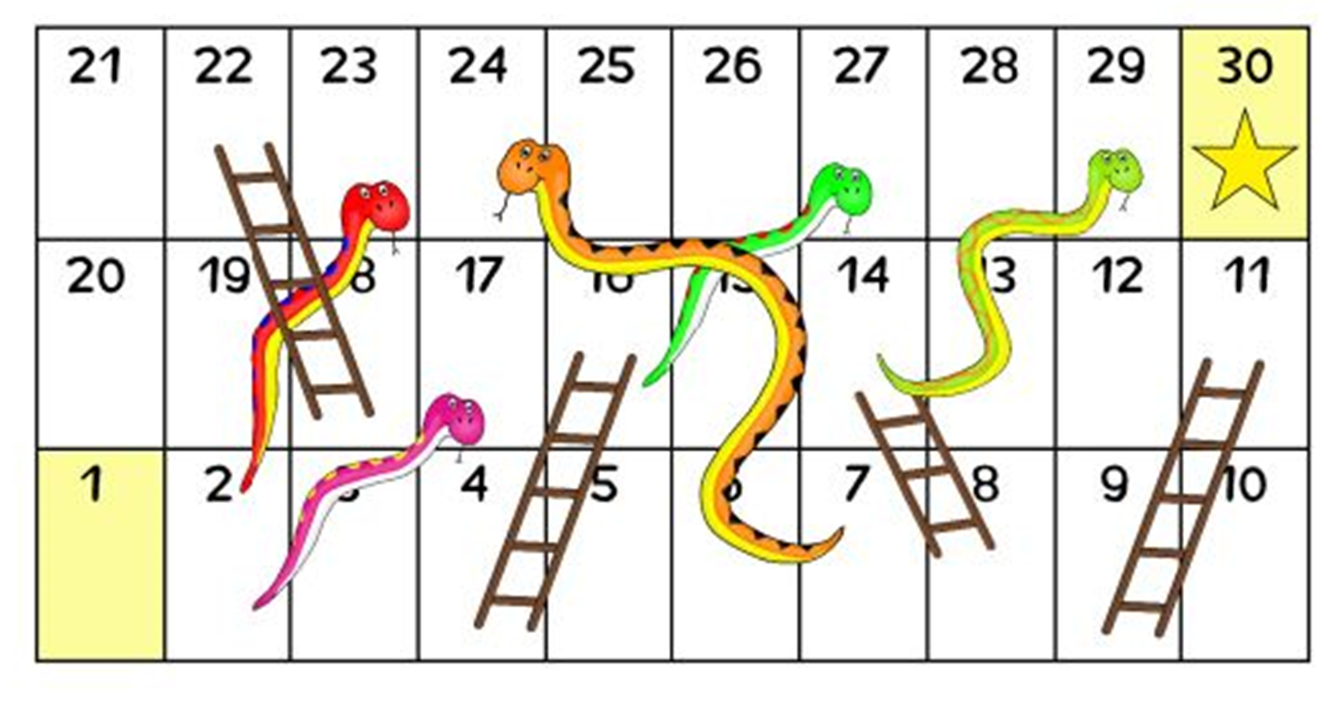
KILL
NUMBER  CHALLENGE | EASY CHALLENGE | MEDIUM CHALLENGE | HARD CHALLLENGE | SUPERSTAR CHALLENGE
1 – GET STARTED
2 - PLANK | 45 secs | 90 sec | 2 mins | 3 mins
3 - PRESS UPS | 10 | 20 | 30 | 50+
4 - BURPEES | 10 | 20 | 30 | 40+
5 – STEP UPS | 30 | 45 | 60 | 75+
6 – PARTNER SELECTS CHALLENGE
7 – BICEP CURLS | 10 | 15 | 25 | 35+
8 – EXERCISE OF YOUR CHOICE
9 – LIFT IT | 15 items | 20 items | 25 items | 35+ items
10 - CRUNCHIES | 15 | 25 | 30 | 40+
11 – SIT UPS | 15 | 25 | 30 | 40+
12 – BOX JUMPS | 10 | 15 | 20 | 25+
13 – PRESS UPS | 10 | 20 | 30 | 50+
14 – PARTNER SELECTS CHALLENGE
15 – PLANK - 1 ARM | 45 secs | 90 sec | 2 mins | 3 mins
16 – YOUR CHOICE
17 – STEP UPS | 30 | 45 | 60 | 75+
18 – BICEP CURLS | 10 | 15 | 25 | 35+
19 - BURPEES | 10 | 20 | 30 | 40+
20 – LIFT IT | 15 items | 20 items | 25 items | 35+ items
21 - CRUNCHIES | 15 | 25 | 30 | 40+
22 – SIT UPS | 15 | 25 | 30 | 40+

NUMBER  CHALLENGE | EASY CHALLENGE | MEDIUM CHALLENGE | HARD CHALLENGE | SUPERSTAR CHALLENGE
1 – GET STARTED
2 – Keepy ups | 5 | 7 | 9 | 10+
3 – Throw & Catch | 10 | 20 | 40 | 40+
4 – Dribble | 3 | 5 | 7 | 8+
5 – Target | 5 POINTS | 9 POINTS | 12 POINTS | 13+ POINTS
6 – PRACTICE YOUR FAVOURITE SKILL |  |  |  | AIM HIGH
7 – Speed bounce | 10 | 15 | 25 | 25+
8 – Weaving run | 3 | 5 | 7 | 8+
9 – Hit the Target | 2 | 4 | 6 | 7+
10 – Throw & Catch | 10 | 20 | 40 | 40+
11 – Sprint | 2 | 4 | 6 | 7+
12 – Pick up Run | 2 | 3 | 6 | 7+
13 – Keepy Ups | 5 | 7 | 9 | 10+
14 – PRACTICE LEAST SUCCESSFUL SKILL |  |  |  | IMPROVE YOUR SCORE
15 – Sprint | 2 | 4 | 6 | 7+
16 – Hit the Target | 2 | 4 | 6 | 7+
17 – TARGET | 5 POINTS | 9 POINTS | 12 POINTS | 13+ POINTS
18 – PRACTICE LEAST SUCCESSFUL SKILL |  |  |  | AIM HIGH
19 – Pick up Run | 2 | 3 | 6 | 7+
20 – Speed bounce | 10 | 15 | 25 | 25+
21 – Throw & Catch | 10 | 20 | 40 | 40+
22 – Hit the Target | 2 | 4 | 6 | 7+
23 – Keepy Ups | 5 | 7 | 9 | 10+
24 – PRACTICE FAVOURITE SKILL – AIM HIGH |  |  |  | IMPROVE YOUR SCORE
25 – Sprint | 2 | 4 | 6 | 7+
26 – Weaving run | 3 | 5 | 7 | 8+
27 – Dribble | 3 | 5 | 7 | 8+
28 – Speed bounce | 10 | 15 | 25 | 25+
29 – Your choice of skill |  |  |  | ENJOY
30 – CHALLENGE COMPLETED

THROW & CATCH AGAINST A WALL
OR TO A PARTNER IN 1 MIN
WEAVING RUN IN 1 MIN USE ANY SUITABLE OBJECTS TO RUN ROUND
KEEPY UPS IN 1 MIN
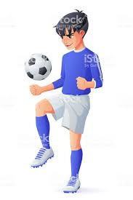
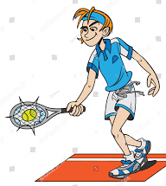
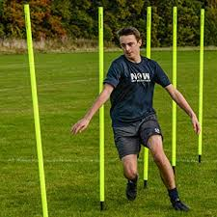
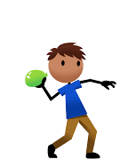

SPEED BOUNCE -2 FOOTED JUMPS OVER OBJECT 15 CMS HIGH
TARGET – HOW MUCH CAN YOU SCORE IN 1 MINUTE

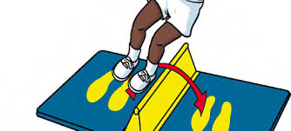
DRIBBLE AROUND CONES 10 STRIDES APART

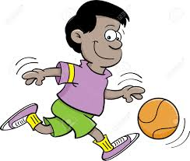
PICK UP OBJECT RUN TO OTHER END PUT IN TARGET PICK UP ANOTHER OBJECT RUN BACK & REPEAT FOR 1 MIN
SPRINT BETWEEN 2 CONES 5 STRIDES APART
TOUCH CONE EACH TIME

HIT THE TARGET
